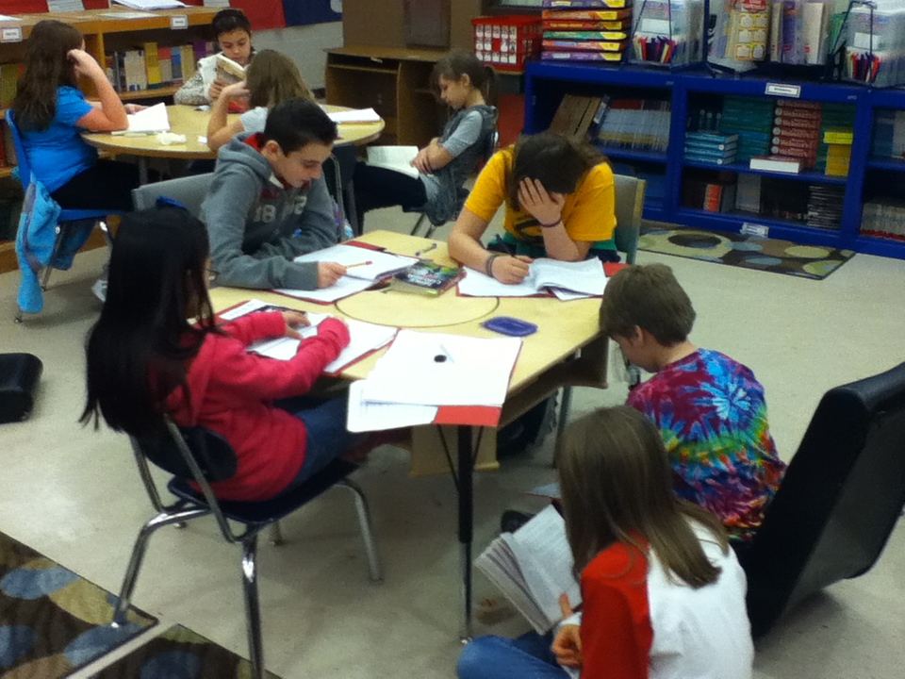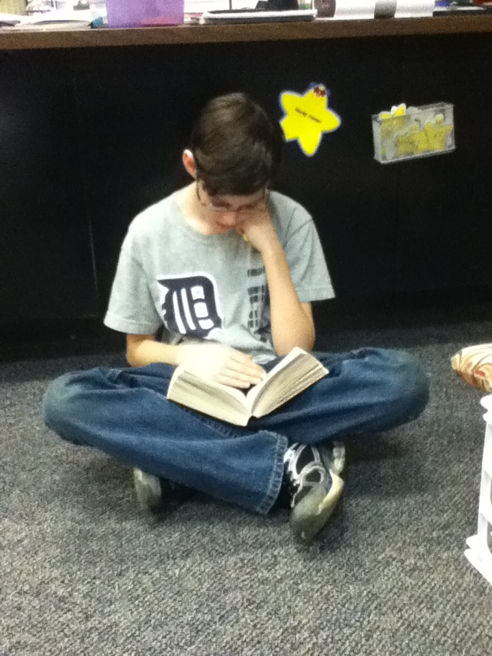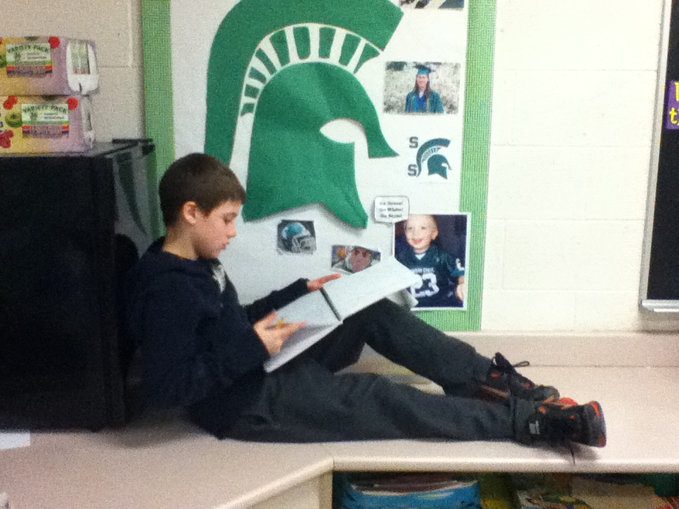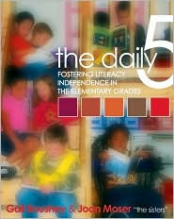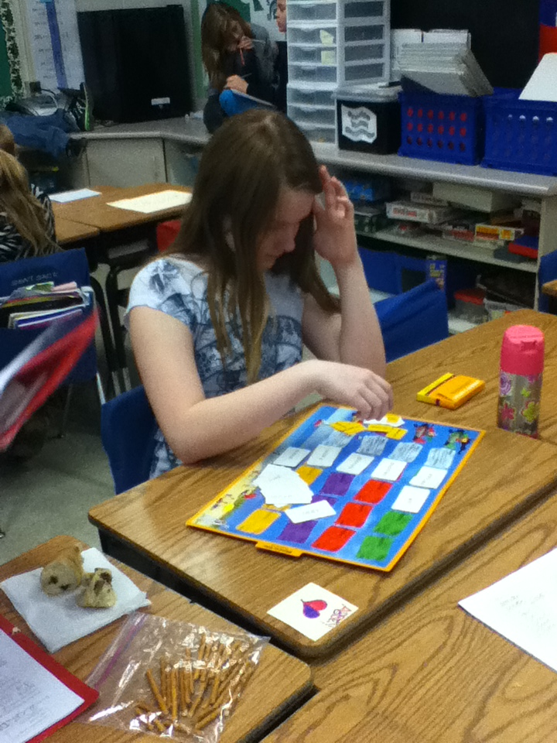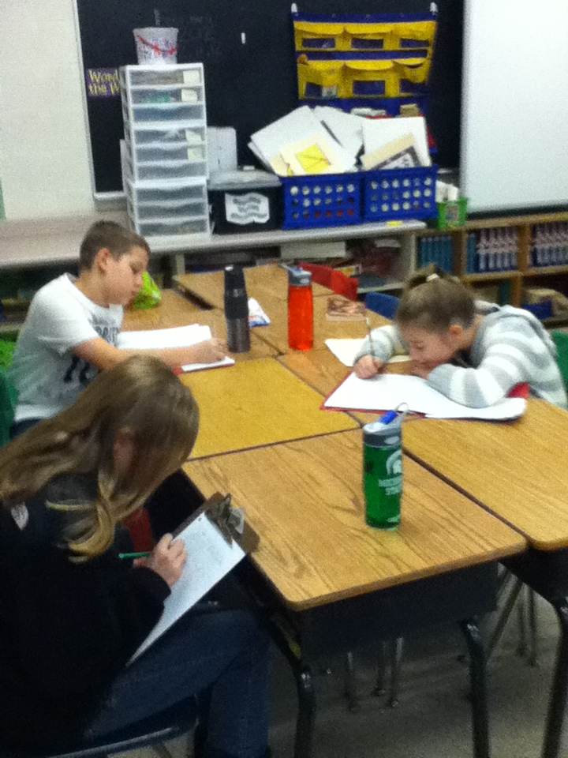

I PICK is an important part of Read to Self – students choose a book that has an important purpose, is interesting to them, that they are able to comprehend, and uses words they are familiar with. Daily 5 strives to make students more independent, lifelong readers by helping them to choose the correct book for a specific purpose. Are they doing research? Exploring a new genre? Or just reading for fun? Read to Self gives kids time to build their vocabulary, their comprehension skills, and their general enjoyment of reading. It is the one aspect of the Daily 5 that should absolutely be practiced in class each day as well as at home.

*Elbow to Elbow,*

*Knee to Knee,*

*Hold the book*

*So call can see!*

Read to Someone can take many forms: students may choose a partner, taking turns reading to one another and checking for understanding, or they may read together and discuss in a group, such as the book club group you see above. In upper elementary, reading to someone often fulfills the “listen to reading” part of the Daily 5; however, some students may still choose to listen to reading by listening to audio books and following along to improve their comprehension of a text.

## Read to Someone &

## Listen to Reading

Creating life-long readers through differentiation, decision-making, and dialogue

### Mrs. Andrea Filip

### Mrs. Sara Loveridge

### Mrs. Kelly Newell

🙞 🙜

# Read to Self

The Daily 5

# Q & A

Students have a chance to explore all aspects of words during this part of the Daily 5. For some students, they may be working on building their vocabulary. Others may spend time working on blends, homophones, and other spelling skills. Others may explore ways to enhance their writing by searching for synonyms and antonyms for commonly used words in their writing. Students will accomplish these goals through reading, writing, and game-based activities.

## Working With Words

During this segment of the Daily 5, students may choose to continue working on a skill or strategy they started in Writer’s Workshop that day. Students may also experiment with new formats of writing, explore mentor texts to draw inspiration for writing from author’s they admire, or choose to revise and enhance previous drafts they have written. Students may also collaborate on pieces, edit, or revise their writing with peers.

## Working With Writing

What does the Daily 5 look like in the classroom?

At the start of Daily 5, the students will gather on the rug for a mini-lesson teaching skills and strategies in one of the main literary areas: reading or writing. Following the mini-lesson, students will choose which component of the Daily 5 they would like to work on independently. As students scatter through the classroom to begin their work, the teacher meets individually or with small groups of students to conference, coach, or instruct guided reading or literature circle groups. At the end of the independent work period, students gather again with the teacher on the carpet to reflect on what was done and be introduced to a new mini-lesson. This cycle continues through the end of Daily 5 time.

Will all students be doing the same assignments and activities?

While all students receive the same mini-lesson, the way the skills and strategies are applied will differ from child to child. Read to Self books will be chosen based on student interest, and guided reading or literature circle books will be based on instructional level.

Will the “Working With Writing” replace Writer’s Workshop in the classroom?

Absolutely not! A separate Writer’s Workshop will take place in the classroom apart from Daily 5. Working With Writing is a chance for students to continue what they started during workshop, experiment with different formats of writing, and work on goals they set with the teacher. Working With Writing is an extension of Writer’s Workshop, not a replacement.