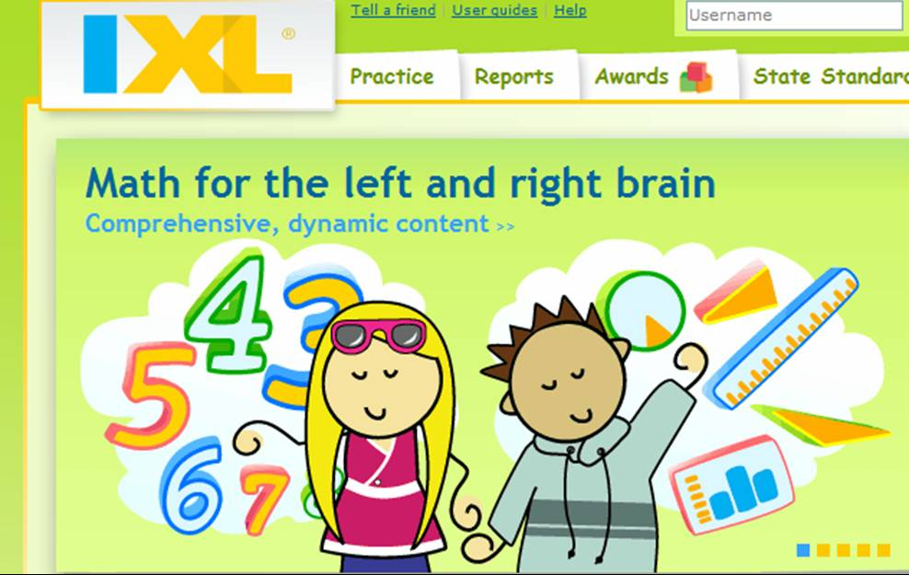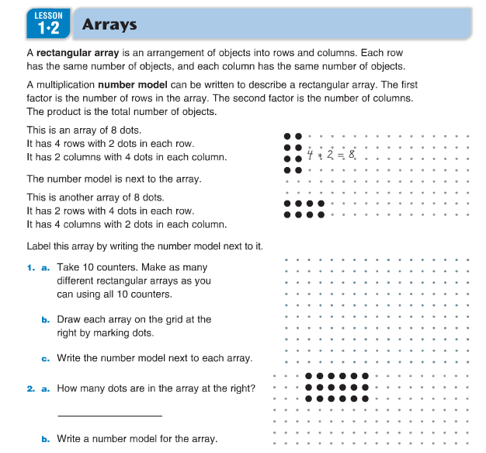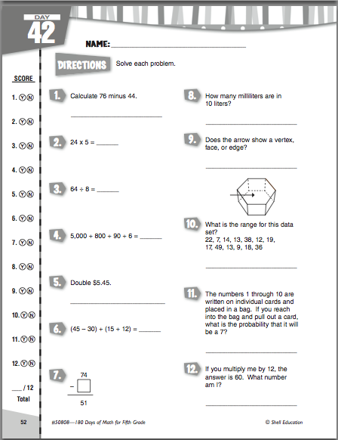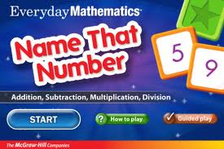

MAP stands for “My Activity Page” and is the center that is the heart of Math MENU, where personalized learning for each student takes place. During MAP, students will work independently or in small groups with the teacher on skills they need extra help on, or will be challenged when the skills for the current and past units have been mastered. Students will keep track of their performance in skills from the current and previous units using Power School, and will use that information to determine the areas they need to improve upon. When working alone, students will utilize IXL and activities from the Upper Elementary Weebly, as well as our class bulletin board. Students will use manipulatives, games, and other math worksheets when meeting with the teacher to work on a particular concept.

At the conclusion of each unit, students will work in groups to solve a “rich task.” These are typically word problems or real life situations that could be approached in different ways or have multiple correct answers. Groups will share solutions and explain their thought processes to each other at the conclusion of the task.

## Rich Tasks

Fraser Public Schools utilizes the *Everyday Math (EDM)* series. Each day, whole-class lessons from the series will be explored, covering the key concept from the current EDM unit. In the Practice Page center, students will collaborate with their classmates in partnerships or small groups to explore the key concept of the day through their EDM Math journal or Study Links pages.

## Practice Pages

M = Measurement and Data

E = Exploring Geometry and Algebra

NU = NUmbers and Operations

For more information, please visit our Upper Elementary Math MENU Weebly at www.mymathmenu.weebly.com

🙞 🙜

### Mrs. Valerie Preston

# MAP

Math MENU

What does the Math MENU look like in the classroom?

Math MENU begins with a schedule displayed on the Promethean Board. During the time that the children work on the Math Message, they will take turns coming up to the board to choose the center they want to start with that day. The Math Message will be reviewed, and then a whole-class lesson on the topic of the day will take place for about 20 minutes. At the conclusion of the lesson, the students will break out into groups for their first center. The center will last about 20 minutes, and then the students will rotate to the next one. The process continues until all three centers are complete. During the center times, students will work independently, with other students, and in small groups with the teacher.

How are math assignments graded?

Students will be exposed to a concept several times and have the chance to practice it alone and with others before they are graded on it. Therefore, not every assignment completed will receive a letter grade. When an assignment is graded, it will appear in Power School under the CONCEPT being taught, NOT the name of the assignment. If a student is unhappy with their score, they have the opportunity to redo a graded assignment, or complete other assignments in the same CONCEPT to improve their score. Math tests at the end of each unit also do not receive just one score – there are multiple grades covering EACH concept on the exam so you and your child can see where they excel and where they may need more work. Students may also improve grades on those concepts by completing other activities covering the same idea and then retest in that concept.

What does MENU stand for?

At the start of each unit, the students will receive a games sheet. Students will need to play each game/activity on the sheet at least once during the unit. Games featured will include ones covering the key concepts from the current unit, but will also have games with skills from each of the Math MENU areas (measurement, data, geometry, algebra, numbers and operations). The games center is meant to help kids increase accuracy and speed in their basic facts and concepts essential to 5th grade.

# Q & A

Dream Box is an amazing Math App that the district has purchased for every child. Please encourage your child to utilize this awesome tool. Students will be using Dream Box at school during centers time as an individualized method to help secure skills they are in need of.

## Dream Box

## Games